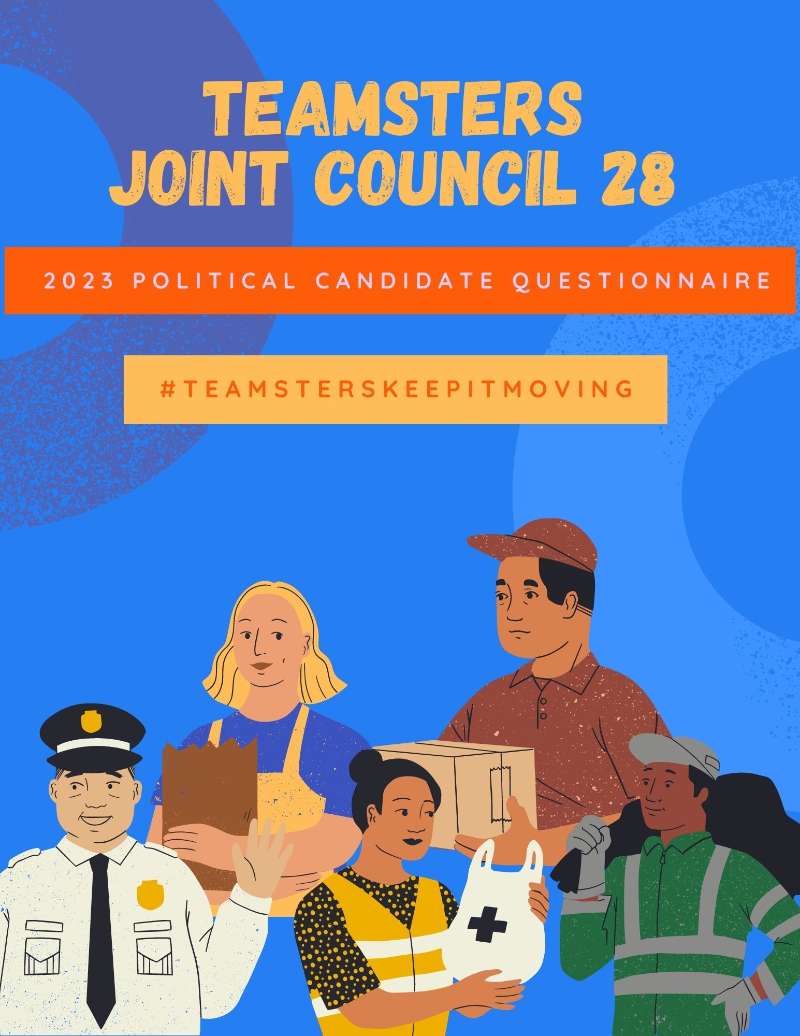

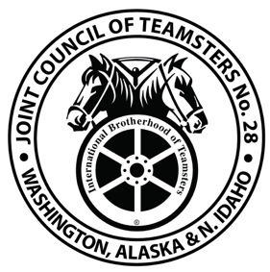

Dear Candidate,
Congratulations on your decision to seek elected office. We appreciate your willingness to engage in the political process and seek solutions to workers' most pressing problems.
The Teamsters is a diverse, compassionate and powerful labor union that improves the lives of the working people by fighting to bring economic justice to the workplace and social justice to our region. Joint Council 28 represents thousands of active and retired union members across Washington, Idaho and Alaska.
The following questionnaire evaluates your support for our platform, and will be used as a guide for our endorsement process. We have a proud record of endorsing Democrats, Republicans, and non-partisan candidates that support our members at the local, state and federal level. We may also use your responses to communicate to our members your stances on issues that are important to working families.
We rely on local elected leaders to advocate for workers rights and their communities. You are key in the fight and are often the pro labor candidates recruited for higher office. Whether you have extensive experience within organized labor or not, we would love to sit down with you and talk about how we can work together to improve the lives of working people. Consider joining the fight to support the people who keep our economy moving.
We appreciate you taking the time to complete this questionnaire and thank you in advance for standing with the working families.

Teamsters Joint Council No. 28
Locals 38, 117, 174, 231, 252, 313, 589, 690, 760, 763, 839 and 959
CONTACT INFORMATION
Name:
Candidate for: (please include position number, if applicable) Current or anticipated opponent(s):
Union Member: Past or Present:
Current and past party affiliation(s):
Consultant/Campaign Manager:
Candidate’s phone contact(s):
Candidate’s email address(es):
Website:
Questionnaire:
Advocacy
All work has dignity and all working people have rights. But right now, billionaires and wealthy corporations are rigging the rules of our economy and taking away our freedom to negotiate together in union for things our families need, like: good jobs, great schools, clean and safe environments, and affordable health care. Now, there are far too many people living paycheck to paycheck, working unreliable hours, with few or no benefits, and without a secure retirement.
In the Pacific Northwest, families should always come first. Whether it's a newborn baby, an elderly parent, or a spouse who's sick, everyone knows being there and providing for your family isn't optional. All working people should have a fair shot at the American dream, with the freedom to negotiate together in a union for better jobs with strong paychecks, good benefits, a secure retirement, and more time to be with family.
What is your connection to the labor movement?
Have you ever worked with a labor organization to achieve/accomplish any of its goals? If so, please explain.
If elected, would you publicly affirm the importance of unions to your community members and urge employers not to interfere when workers are deciding whether to form or join a union ? Y/N
REPEALING PREVAILING WAGE AND APPRENTICESHIP UTILIZATION
Prevailing wage laws and strong apprenticeship utilization standards are critical to ensuring young people have access to family-wage jobs in the building and construction trades. Proposals to undermine prevailing wage laws and to lower apprenticeship utilization requirements are often introduced in late-stage budget negotiations during the legislative session. These bills would eviscerate prevailing wage by allowing local governments, special districts and private contractors to exempt themselves, causing a race towards the bottom.
I support maintaining and upholding prevailing wage policy? Y/N

Responsible Government Operations
Local governments have the fiduciary responsibility to spend taxpayer dollars wisely. They also have the obligation, as institutions of the people, to act equitably and responsibly with their own employees. The dollars that local governments spend should not just create quality infrastructure and necessary services to tax payers — taxpayer dollars should also support area businesses, especially those who pay their workers competitively and provide healthcare. When local governments sell out projects to the lowest bidder, not only do they decrease the quality of government services, but they also erode the living standards in the very communities they were elected to protect and improve.
If elected, would you oppose the privatization of public services? Y/N
How would you balance the budget in your governmental entity if faced with a deficit, revenue shortfall, or other financial challenge ?
BLUE GREEN POLICY
We must strive to create and retain millions of high-quality jobs while putting forward bold solutions to climate change. Working people should not suffer economically due to efforts to tackle climate change. The boldness of any plan requires that the workers and communities impacted are afforded a just and viable transition to safe, high- quality, union jobs.
What policies would you put in place to ensure that this promising source of employment for constituents continues to grow as true just transition?
LABOR, LAW ENFORCEMENT & Public Safety
The labor movement, as an integral part of our communities and the representative of many law enforcement officers, has a unique role to play in changing public safety. It is our job to build productive, positive, and trusting relationships.
We must use our unions to advocate for meaningful change that keeps communities and public safety professionals safe. All workers, including law enforcement officers, are entitled to a union and the right to bargain collectively. This is the cornerstone of the labor movement and a key American value that will play a critical role to advance discovering a new vision of implementing public safety for all.
How will you support policing, both officers/workers and constituents in our region around public safety? What is the most pressing public safety issue facing your jurisdiction and how would you address it?

